Ohm’s Law
To do the experiment by using PHET interactive simulation follow the following steps:
- Click on the following link from PHeT Colorado Simulation
https://phet.colorado.edu/en/simulation/circuit-construction-kit-dc

- Download Circuit Construction Kit: DC
- Click on Lab
- Choose Conventional Current
- Use the components in the left side to build the circuit shown below:
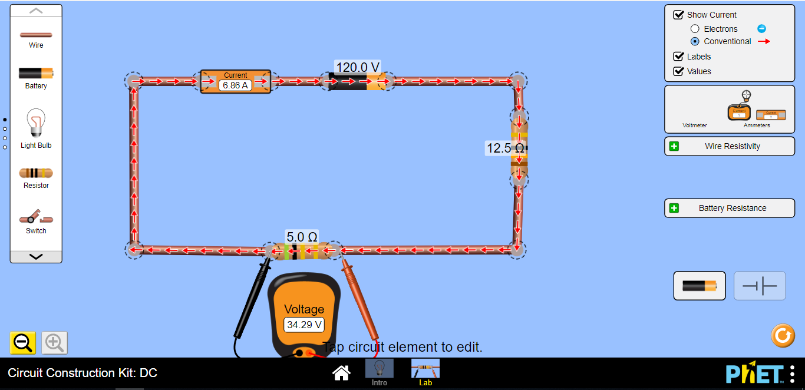
R_{e} (rheostat) Variable resistor
R₁ = 5Ω

- Click on the resistor (R₁) and fix it at 5Ω. That is R₁ = 5Ω.
- Click on the Battery and fix it at 120V.
- Click on the Voltmeter from the right side and drag it to measure (V₁) the voltage across R₁.
- Click on the Ammeter from the right side and drag it and put it in series with R₁ (before or after R₁) to measure (I₁).
- Vary the rheostat () to obtain 6 different readings of the electric current (I) and the corresponding values of the voltage (V). Then Record the values into table 1.
- Replace R₁ by R₂=10Ω as shown below:

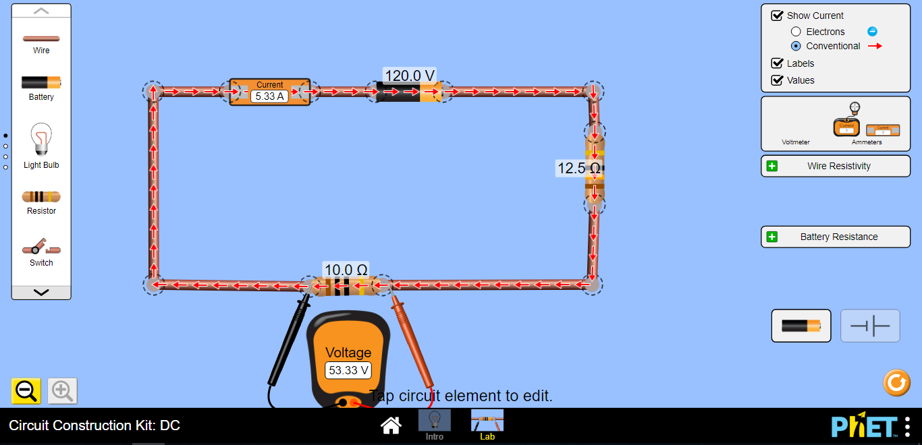

- Again vary the rheostat () to obtain 6 different readings of the electric current (I) and the corresponding values of the voltage (V). Then Record the values into table 1.

- Connect R₁=5Ω and R₂=10Ω in series as shown below, and again vary the rheostat () to obtain 6 different readings of the electric current (I) and the corresponding values of the voltage (V). Then Record the values into table 1.
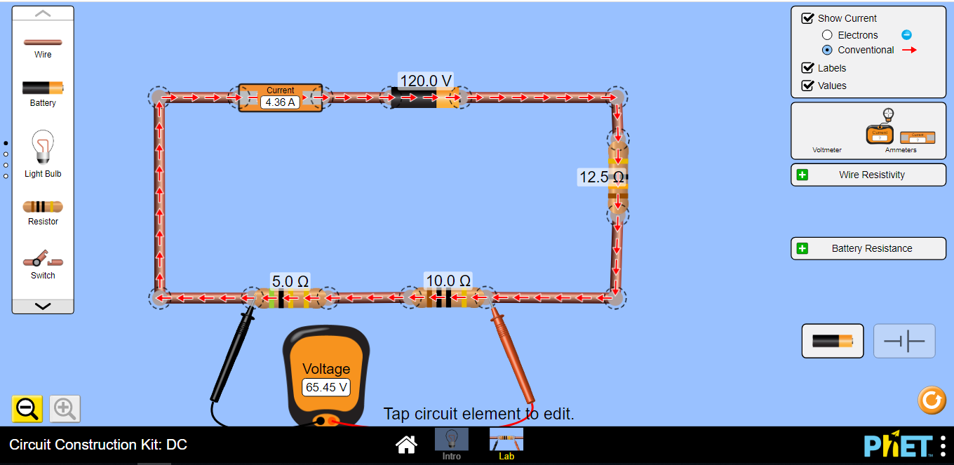
R₁ and R₂ in Series Connection

- Now connect R₁=5Ω and R₂=10Ω in parallel as shown below, and also vary the rheostat () to obtain 6 different readings of the electric current (I) and the corresponding values of the voltage (V). Then Record the values into table 1.
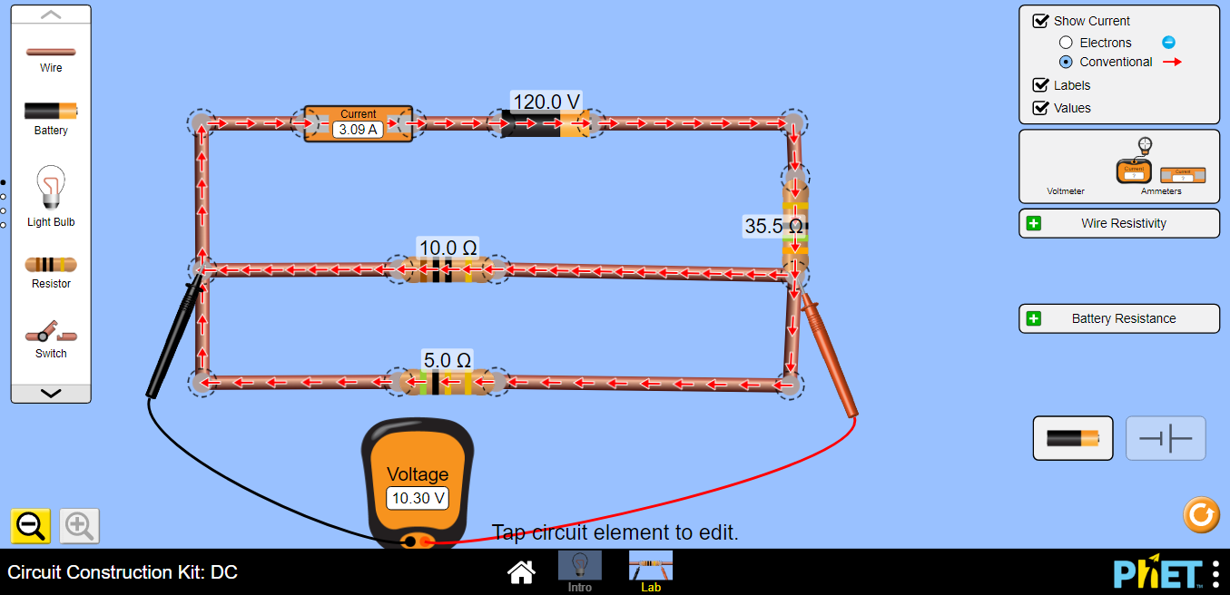
R₁ and R₂in parallel connection

Note that the Voltmeter is always connected in parallel with the element while the Ammeter in series
Table (1)
R₁ (Ω) |  | R₂ (Ω) |  | Equivalent Resistance  in series |  | Equivalent Resistance  in parallel
V(V) | I (A) | V(V) | I (A) | V(V) | I (A) | V(V) | I (A)

  - Plot a graph V versus I for each case?
  - Does the best straight lines passes through the origin? Explain.

  - Calculate the slope of each graph and determine the resistance (R) from the graph (slope) and experimentally? Record the results into table 2.

Table (2)
 | Slope | The experimental Resistance ( Ω ) | δ %
Graph 1 |  | R₁ experimentally =
Graph 2 |  | R₂ experimentally =
Graph 3 |  | R_{eq} experimentally =
Graph 4 |  | R_{eq} experimentally =

  - What is the difference between Ohmic resistor and a Non-Ohmic resistor?

Ohmic:

Non-ohmic

  - When the potential difference, V, across an ohmic resistor is increased what effect does this have on:

  - The electric current (I)

  - The resistance (R)

Conclusions:

